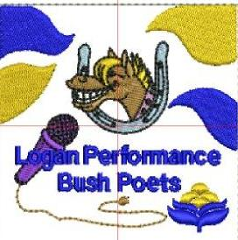
LOGAN PERFORMANCE BUSH POETS
Presents
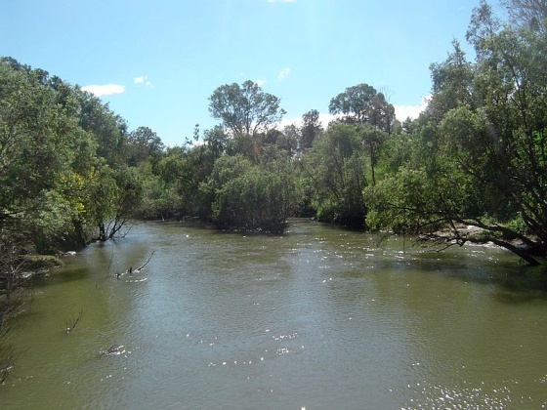

LOGAN’S MUDDY RIVER PERFORMANCE POETRY
COMPETITION

The MUDDY RIVER PERFORMANCE POETRY COMPETITION
Saturday September 21st to be held at the Beenleigh Show in the Phoenix Ensemble Theatre in the Showgrounds, James St, Beenleigh.
“ All poetry entrants will receive a free entry ticket”
TIMES ARE A GUIDE ONLY.
- 9.00 am The Muddy River ‘Best of Bush Poetry’ Award Bush Poem written at any time by someone else, Classical or Modern (Novice included $25 and Certificate) $5
Poem/author____________________________________________________________________
(OPEN Trophy/Certificates $100/$50/$20) $10
2. 10.30. The Jim Tonkin MEMORIAL Comedy Bush Poetry Award
Poems can be written by poet or someone else. (Winner chosen by audience with a vote on slips of paper provided winners name placed on New Perpetual trophy)
POEM/ Author________________________________ _ (Trophy/Certificates and$ 100/$50/20 $10

11.30 LUNCH

3. 12.30. The Muddy River Slam or Rap PERFORMANCE EVENT (2-3 minutes)
Slam a ‘powerful’ two to three minute performance, best if known, does not have to rhyme, audience engagement allowed.
Rap A poem with a distinct and repetitive rhythm. Rhythm is key, usually memorised (Trophy/Certificates and 100/$50/$20) FREE
4. 1.30 The Muddy River Original Bush Poetry AWARD poem written by
Poet. (Novice /Certificate $25) $5
(OPEN Trophy/Certificates and $100/$50/$20) $10

5.2.30 Muddy River One Minute Championship (Trophy and $20) $5
Must contain words MIGHTY, WONDER, DANCING, PARROT, CUTE

The Champions Awards
The highest point scorer, in events 1, and 4 bush poetry events will be awarded the Muddy River Champion trophy and a cash prize of $100
The highest point scorer in events 1 and 5 bush poetry events from the Logan Club - will be awarded the Logan’s Muddy River Legend Trophy, a Winners red polo shirt and $50 cash prize.
The Jim Tonkin Memorial Perpetual Trophy to the winner of the comedy event.
When the competition is over poets can enjoy all the highlights of the ‘Beenleigh Country Show’
Alternatively competitors and partners are invited to join the Logan Performance Bush Poets at the Beenleigh Tavern 114 Distillery Rd for dinner. (at own expense)
ENTRIES
Send entries to: kgeraldine450@gmail.com
Or post to Geraldine King - 35 John St Jimboomba 4280 by September 9^{th or before.}
Name: ________________________ PHONE ___________EMAIL____________________
Address_____________________________________________________-
For more information ring Gerry on 0499942922
(Entry not accepted without payment. Monies to be returned if event is cancelled)
Bank TRANSFERS Logan Performance Bush Poets
Bendigo Bank BSB: 633000 Account number: 165263591 (Must write your name on this deposit/transfer)
Conditions of Entry
1) Judges’ decision is final and no correspondence will be entered into.
2) No late entries will be accepted there will be 10 max in each bush poetry event.
3) Entrants must be 17 or over (except in RAP/ Slam and one minute.)
4) Poets must acknowledge other poets work and seek permission to use poems (where possible).
5) Bush Poems do not necessarily have to have a heritage or bush theme but they must be
distinctly and undeniably Australian and must have rhyme, and metre.
6) Time limit (as specified) or 6 minutes for bush poetry events
7) Poems that are lewd or socially unaccepted will be disqualified

